**A**

**PROJECT**

**REPORT**

**ON**

**“E-COMMERCE WEBSITE”**

**SUBMITTED TO**

**Banaskantha District Kelavani Mandal**

**Sanchalit**

**Smt. B.K. Mehta I.T. Centre (BCA College)**

**OPP. S.T.**

**WORKSHOP,**

**HIGHWAY,**

**PALANPUR -385001.**



**As a Partial fulfilment of the course of**

BACHELOR OF COMPUTER APPLICATION

YEAR :- 2024 – 2025

**Banaskantha District Kelavani Mandal Sanchalit**

**Smt. B.K. Mehta I.T. Centre (BCA College)**

OPP. S.T. WORKSHOP, HIGHWAY, PALANPUR -385001.

**Affiliated TO**

(Hemchandracharya North Gujarat University, Patan)



**CERTIFICATE**

**TO WHOM SO EVER IT MAY CONCERN**

This is to certify that following student of B.C.A has completed his project work on “E-Commerce Website” satisfactorily in partial fulfilment of requirement of BECHELOR OF COMPUTER APPLICATION of Hemchandracharya North Gujarat University, Patan in the year 2024 – 2025.

Serial No Name of Student Roll No Exam No

|  |  |  |  |
| --- | --- | --- | --- |
| 1 | Hitesh Mali | 53 | 358 |

**Project Guide**

Shri. Parvin V. Ami

**Principal**

Dr. Namrata S. Gupta

(Smt. B.K. Mehta I.T. Centre BCA College , Palanpur )

**INDEX**

|  |  |  |
| --- | --- | --- |
| **SR.NO** | **DESCRIPTION** | **PAGE NO** |
| 1 | PROJECT PROFILE | 4 |
| 2 | ABSTRACT | 5 |
| 3 | ACKNOWLEDMENT | 6 |
| 4 | INTRODUCTION | 7 |
| 5 | OVERALL DESCRIPTION | 8 |
| 6 | DEPLOYMENT TIME REQUIREMENTS | 11 |
| 7 | SYSTEM REQUREMENTS | 12 |
| 8 | DATA MANAGEMENT | 20 |
| 9 | E-COMMERCE WEBSITE | 24 |
| 10 | REFERENCES | 43 |

**PROJECT PROFILE**

|  |  |
| --- | --- |
| **PROJECT TITAL** | **E-Commerce Website** |
| **OBJECTIVE** | e-commerce website is to provide a seamless shopping experience, maximize conversions, enhance customer satisfaction, increase brand visibility, and drive consistent sales growth. |
| **DESIGN** | HTML, CSS, JAVASCRIPT |
| **LANGUAGE** | PHP |
| **DATABASE** | MYSQL |
| **SOFTWARE** | VISUAL STUDIO CODE |
| **SERVER** | APACHE |
| **DOCUMENTTATION TOOL** | MS OFFICE |
| **DEVELOPED BY** | HITESH MALI [53] |
| **PROJECT GUIDE** | SHRI. PARVIN V. AMI |
| **SUBMITTED TO** | B.K. MEHTA I.T CENTER BCA COLLEGE PALANPUR |
| **TEAM SIZE** | 1 |
| **PROJECT DURATION** | 80 hours |

**ABSTRACT**

E-Commerce Website for abstract art serves as a digital marketplace where artists and buyers can connect over unique and diverse abstract artworks. The platform provides artists with a dedicated space to showcase their creations, including paintings, digital art, sculptures, and other abstract forms. With detailed product descriptions, high-quality images, and a simple purchasing process, the website aims to offer a rich, visually appealing experience for art lovers.

The website is designed with an intuitive interface to ensure a seamless browsing experience. Users can filter and search for artworks based on style, color palette, size, and price, allowing them to easily discover pieces that match their preferences. The site supports secure transactions, offering multiple payment options to cater to a global customer base. A personalized recommendation system suggests relevant artworks based on user behavior and preferences, helping both casual browsers and serious buyers find art that resonates with them.

Beyond transactions, the e-commerce platform also fosters an online art community. It includes features such as artist profiles, blogs, and galleries, allowing users to learn more about the stories behind each piece of abstract art. The website may also offer educational content about abstract art, providing insights into techniques, trends, and the cultural significance of abstract art movements. By bridging the gap between artists and collectors, the website promotes the growth and appreciation of abstract art in the digital age.

**ACKNOWLEDGEMENT**

* In completing this graduate project, we have been fortunate to have received invaluable help, support, and encouragement from numerous individuals, whose contributions have been instrumental in shaping this endeavor. we would like to express our sincere gratitude to each of them.
* First and foremost, we extend my heartfelt appreciation to Dr. Namrata S. Gupta, not only for her exemplary guidance and expertise as the principal of our institution but also for her unwavering support and mentorship throughout this project. Her insights and encouragement have been invaluable in steering me through the complexities of this undertaking.
* We would also like to extend my gratitude to Parvin Madam, whose dedication as a professor and supporter has significantly enriched my academic journey. His constructive feedback and encouragement have been pivotal in shaping the direction of this project.
* Furthermore, we extend our thanks to all the staff members whose consistent support and assistance have been invaluable. Their willingness to lend a helping hand and offer guidance whenever needed have been deeply appreciated.

1. **INTRODUCTION**

E-Commerce Website for abstract art serves as a dynamic platform where artists can showcase and sell their unique abstract creations to a global audience. It provides a convenient and accessible way for art lovers to discover and purchase original abstract artworks, ranging from paintings to sculptures and digital pieces.

The website is designed with user experience in mind, offering intuitive navigation and advanced filtering options to help buyers easily find artwork that fits their preferences. High-quality images, detailed descriptions, and artist profiles further enhance the shopping experience, allowing users to make informed purchasing decisions.

The website is designed with user experience in mind, offering intuitive navigation and advanced filtering options to help buyers easily find artwork that fits their preferences. High-quality images, detailed descriptions, and artist profiles further enhance the shopping experience, allowing users to make informed purchasing decisions.

In addition to its marketplace functionality, the website fosters a sense of community by providing artists with the opportunity to engage with their audience. It also allows buyers to explore artist stories, blogs, and upcoming events, encouraging deeper connections and appreciation for abstract art.

**2.0 OVERALL DESCRIPTION:**

**2.1 Description:**

* Any user can register and view available products.
* Only registered user can order in website.
* There are two roles available: User and Admin.

1. User can view product and information, make order in Website.
2. Admin can add, edit, and delete products, manage orders, and view user information.

**2.2 Scope:**

* The website will enable a single seller to showcase and sell abstract art.
* It will provide a simple and user-friendly interface for customers to browse and purchase artwork.
* The platform will include secure payment options for smooth transactions between the seller and buyers.

**2.3 Using the Code:**

* Attach the database to your MySQL Server.
* Run the application using Eclipse and Apache Tomcat server.
* Locate the database and configure it properly before starting the application.

**2.4 Web Pages Details:**

* Admin Pages:
* Admin Login Page
* Admin Dashboard Page
* Admin Products Page
* Messages Page
* Placed Orders Page
* Register Admin Page
* Update Products Page
* User Accounts Page
* Update Profile Page
* Admin Logout Page
* User Pages:
* Home Page
* About Page
* User Register Page
* User Login Page
* Cart Page
* Category Page
* Checkout Page
* Contact Page
* Orders Page
* Quick View Page
* Shop Page
* Search Page
* Update User Page
* User Logout Page
* Wishlist Page

**3.0 DEPLOYMENT TIME REQUIREMENT**

|  |  |  |
| --- | --- | --- |
| **Hardware**  **Requirement** | **Server Side (Minimum Requirement)** | |
| Processor | Intel core i3 |
| RAM | 4GB |
| HDD | 256GB |
| **Client Side (Minimum Requirement)** | |
| Processor | Intel i3 |
| RAM | 4GB |
| HDD | 256GB |

|  |  |  |
| --- | --- | --- |
| **Software**  **Requirement** | **Server Side (Minimum Requirement)** | |
| Operating System | Windows , Linux |
| Database | MYSQL |
| **Client Side (Minimum Requirement)** | |
| Operating System | Windows |
| Browser | Any Browser |

**4.0 SYSTEM REQUIREMENTS**

**4.1 Data Flow Diagram**

* A data flow diagram is a graphical view of how data is processed in a system in terms of input and output.
* The Data flow diagram (DFD) contain some symbol for drawing data flow diagram.
* **CONTEXT LEVE DFD – 0 LEVELS:**

**Admin**

**User**

Request for

Login

Response

Response

Request for Registration

* Admin 1st  level DFD

Admin

Request for Login

Response

Check for Login

Reply

Reply

Manage Order

Add/Edit Product

Manage Users

Manage Users

Insert Product

Response

Users_info

Orders_info

Display Data

Insert Order

Reply

Admin_info

Products_info

Display Data

Response

* Admin 2nd level DFD

Admin

Request for Login

Response

Check for Login

Reply

Reply

Remove Data

Insert Data

Products_info

Products_info

Reply

Update info

Reply

Admin_info

Products_info

* Admin 2nd level DFD

Admin

Request for Login

Response

Check for Login

Reply

Reply

Request for View

Orders_info

Reply

Admin_info

Orders_info

Request for

Conform/Cancel

* Admin 2nd Level DFD

Admin

Request for Login

Response

Check for Login

Reply

Reply

Request for View

Users_info

Reply

Admin_info

Users_info

Remove Data

* User 1st Level DFD

Product_info

User

User_info

User_info

Order_info

User_info

Product_info

Request to Login

Response

Reply

Search Product

Check Detail

Reply

Insert Data

Insert Data

Reply

Reply

Reply

Reply

Insert Data

View Detail

Display Data

Update Profile

Response

Insert Data

Check Detail

Response

Add to Cart Data

Checkout add Data

Response

Response

* User 2nd Level DFD

Users_info

User

Users_info

Users_info

Request to Login

Response

Check Detail

Reply

Request for View

Reply

Update Password

Reply

* User 2nd Level DFD

Product_info

User

Products_info

Orders_info

Orders_info

Request to login

Response

Check Detail

Reply

Request for View

Reply

Insert Data

Reply

Insert Data

Reply

**5.0 Data Management**

**5.1 Data Description**

This database consists of

* User and Admin information is added to database with Unique ID based on their roles**.**

**5.2 Database Table**

* The design of the database was similar to the analysis phase. The database has been developed using SQL Server.
* These are the main tables in the application and others are lookup and query tables.
* Admin_info Table

|  |  |  |  |
| --- | --- | --- | --- |
| Column Name | Data Type | Index | Description |
| Id | Int | Primary key | Admin ID |
| name | varchar(100) | Not null | Admin User Name |
| password | varchar(100) | Not null | Password |

* User_info Table

|  |  |  |  |
| --- | --- | --- | --- |
| Column Name | Data Type | Index | Description |
| id | Int | Primary key | User ID |
| name | varchar(25) | Not null | Name |
| email | varchar(25) | Not null | Email |
| password | varchar(200) | Not null | Password |

* Cart Table

|  |  |  |  |
| --- | --- | --- | --- |
| Column Name | Data Type | Index | Description |
| id | Int | Primary key | Cart ID |
| User_id | Int | Not null | User ID |
| pid | Int | Not null | Product ID |
| name | varchar(100) | Not null | Name |
| price | Int | Not null | Price |
| quantity | Int | Not null | Quantity |
| image | varchar(100) | Not null | Image |

* Message Table

|  |  |  |  |
| --- | --- | --- | --- |
| Column Name | Data Type | Index | Description |
| id | Int | Primary key | Message ID |
| user_id | Int | Not null | User ID |
| name | varchar(100) | Not null | Name |
| email | varchar(100) | Not null | Email |
| number | varchar(12) | Not null | Number |
| message | varchar(500) | Not null | Message |

* Orders Table

|  |  |  |  |
| --- | --- | --- | --- |
| Column Name | Data Type | Index | Description |
| id | Int | Primary key | Order ID |
| User_id | Int | Not null | User ID |
| name | varchar(100) | Not null | Name |
| number | varchar(100) | Not null | Number |
| email | varchar(100) | Not null | Email |
| method | varchar(100) | Not null | Payment Method |
| address | varchar(100) | Not null | Address |
| total_products | varchar(100) | Not null | Total Product |
| total_price | Int | Not null | Total Price |
| placed_on | date | Not null | Order Date |
| payment_status | varchar(100) | Not null | Payment Status |

* Products Table

|  |  |  |  |
| --- | --- | --- | --- |
| Column Name | Data Type | Index | Description |
| id | Int | Primary key | Product ID |
| name | varchar(100) | Not null | Product Name |
| details | varchar(100) | Not null | Product Details |
| price | int | Not null | Product Price |
| Image_01 | varchar(100) | Not null | Image 1 |
| Image_02 | varchar(100) | Not null | Image 2 |
| Image_03 | varchar(100) | Not null | Image 3 |

* Wishlist Table

|  |  |  |  |
| --- | --- | --- | --- |
| Column Name | Data Type | Index | Description |
| Id | Int | Primary key | Wishlist ID |
| user_id | Int | Not null | User ID |
| pid | Int | Not null | Product ID |
| name | varchar(100) | Not null | Product Name |
| price | int | Not null | Product Price |
| image | varchar(100) | Not null | Product Image |

**6.0 E-Commerce Website**

Home Page

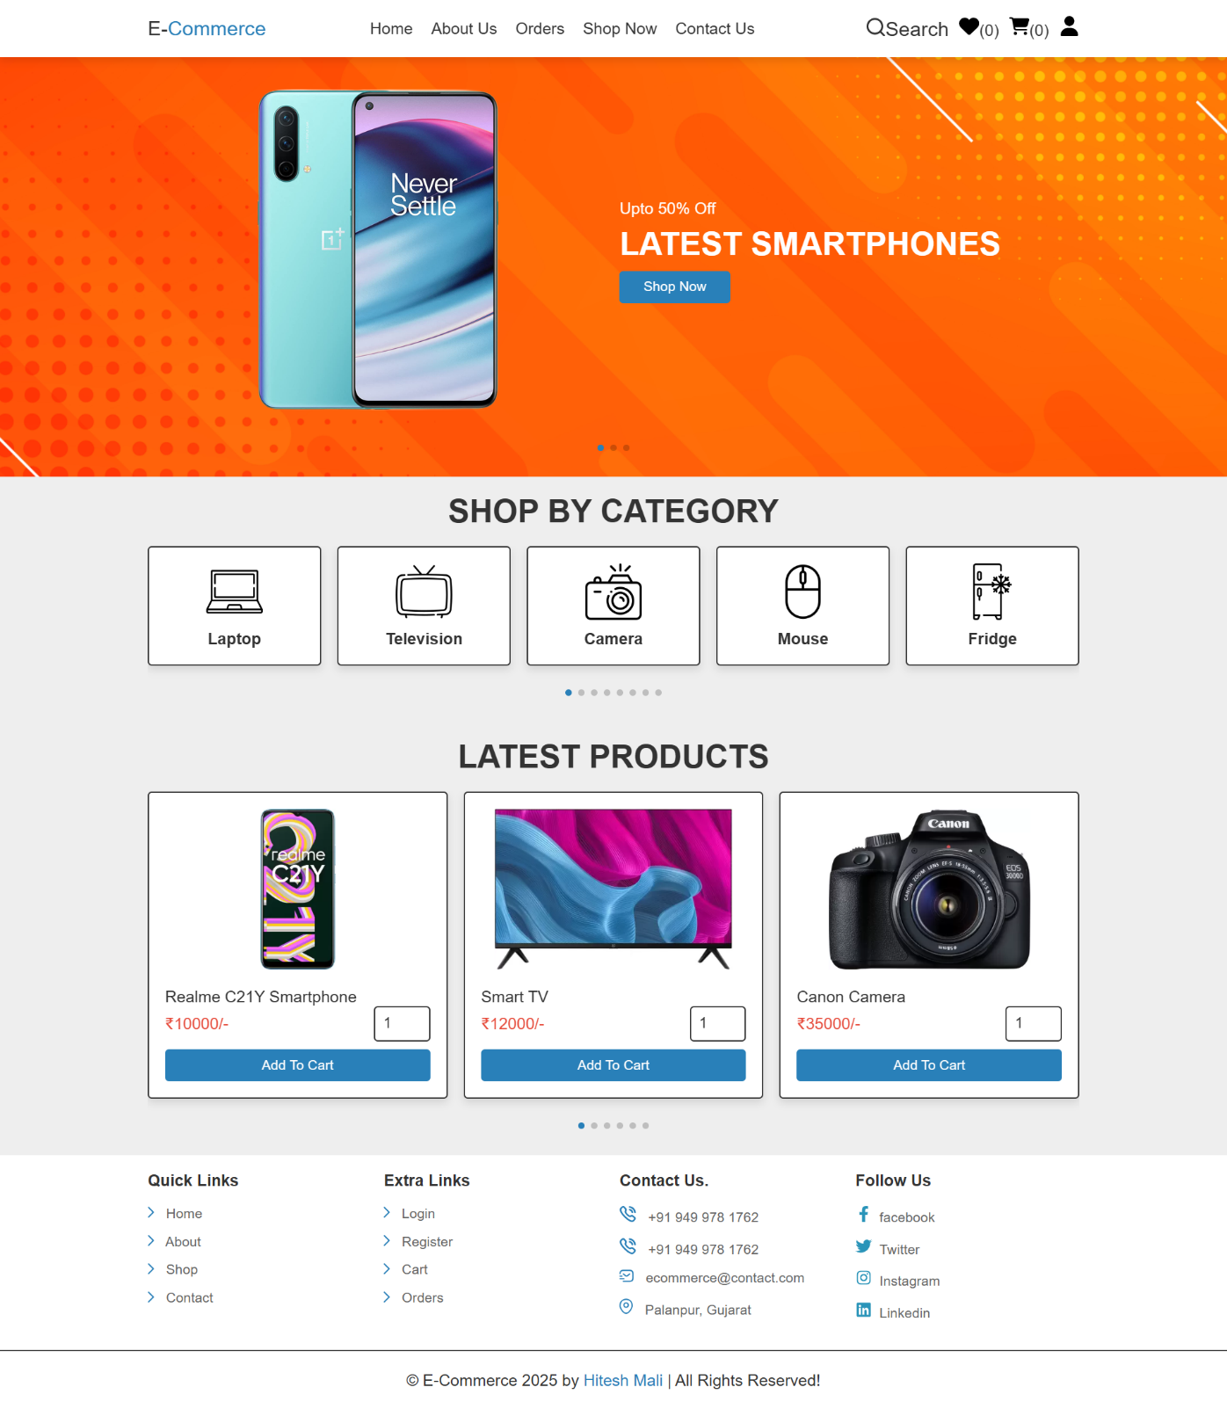

Admin Login Page

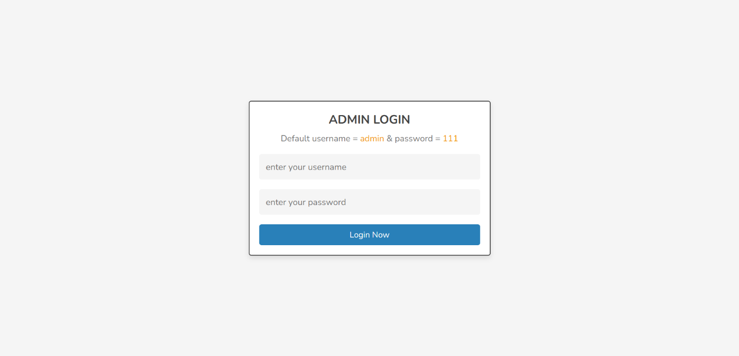

Admin Dashboard Page

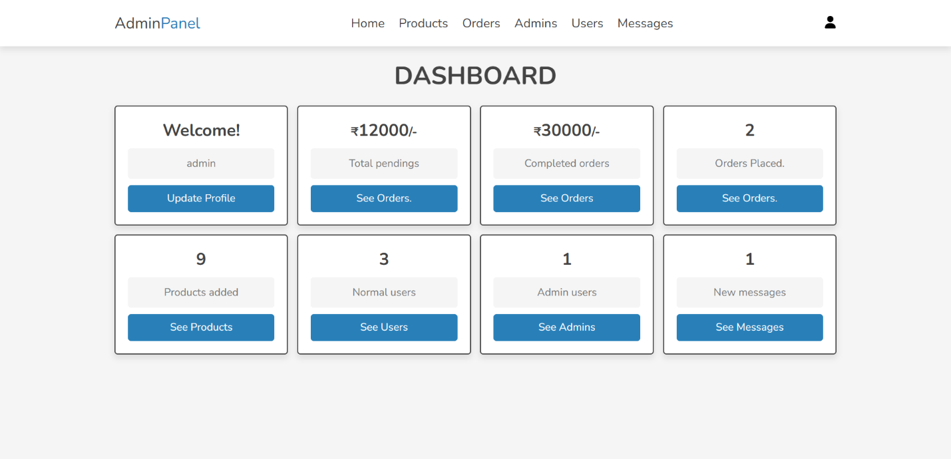

Admin Accounts Page

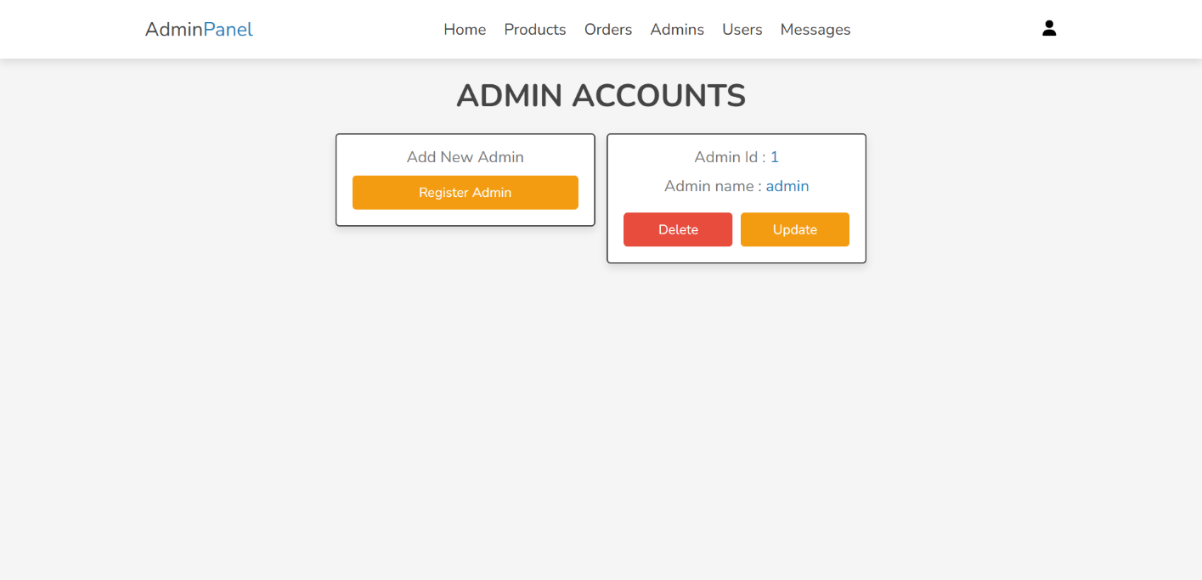

Admin Change Password Page

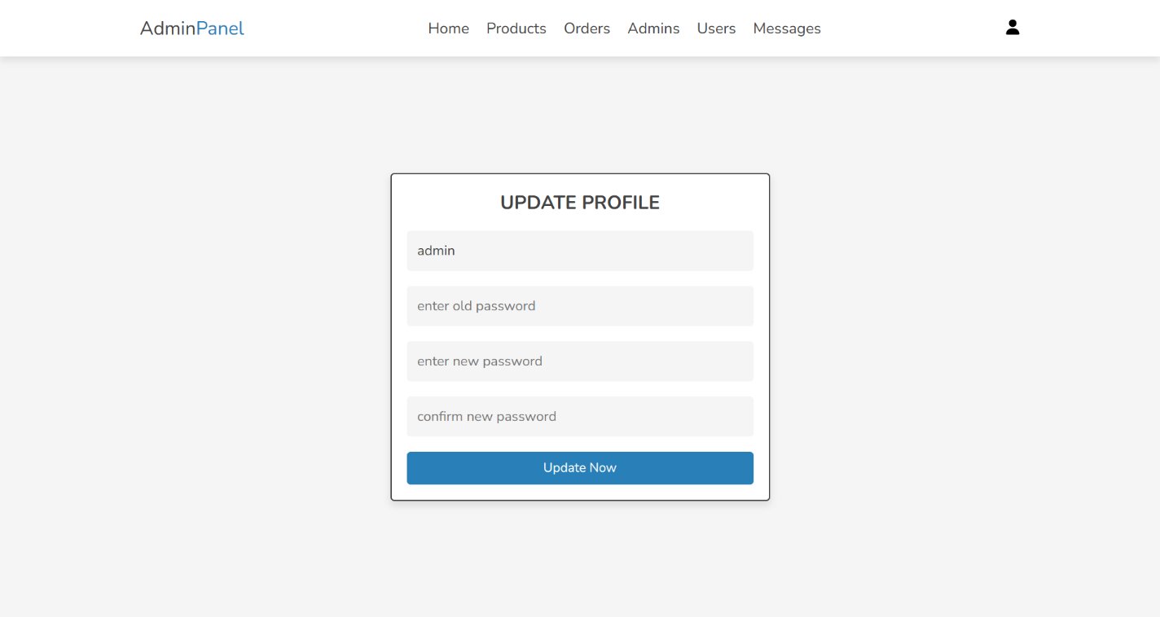

Admin Product Page

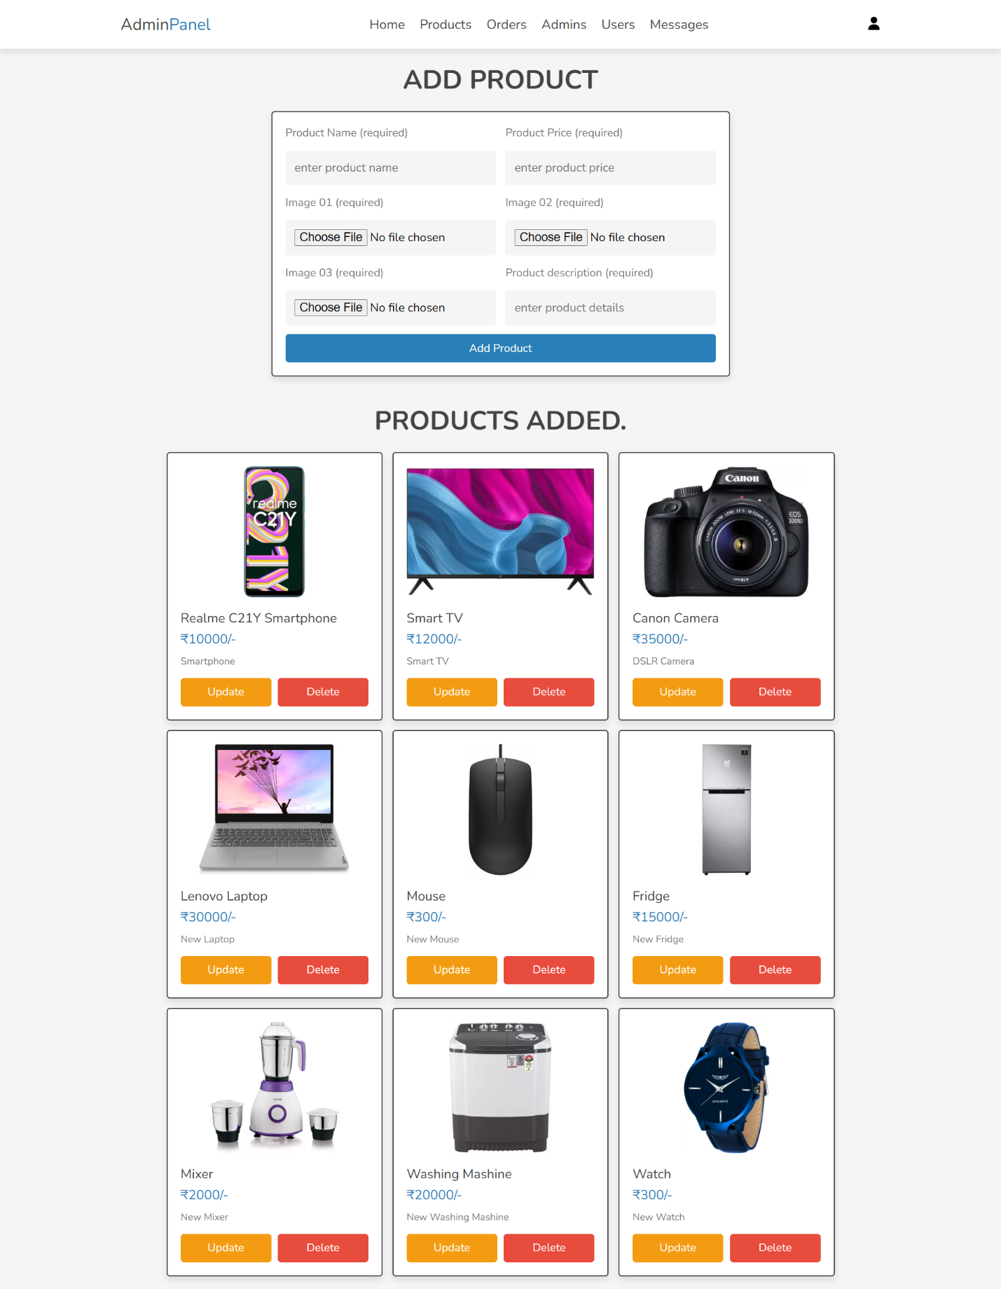

Admin Update Product Page

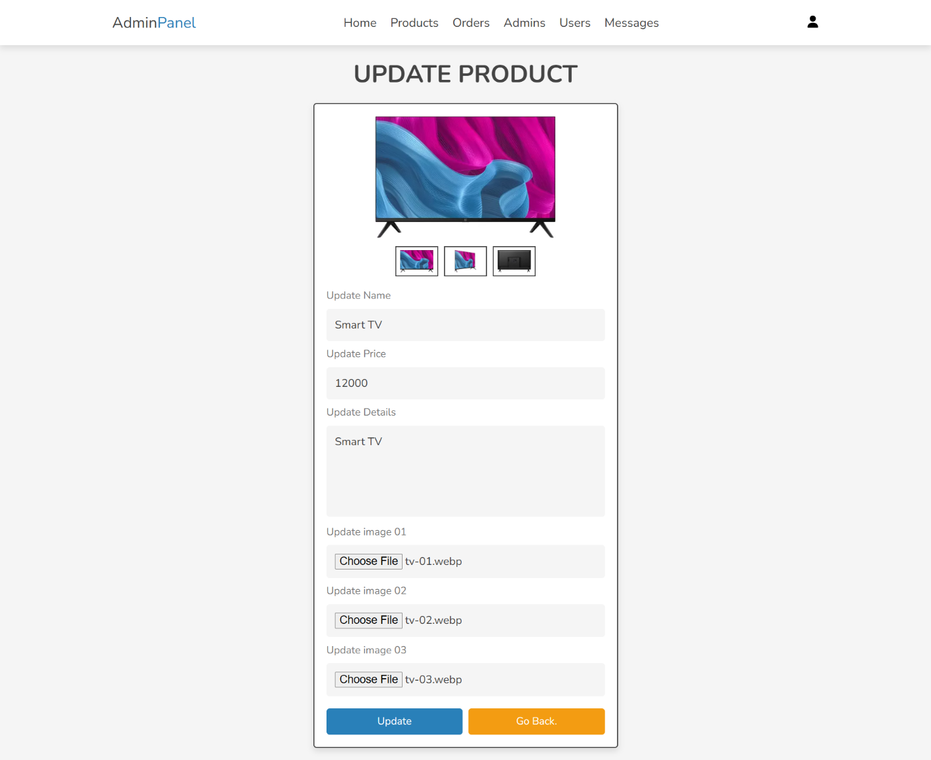

Admin Orders Page

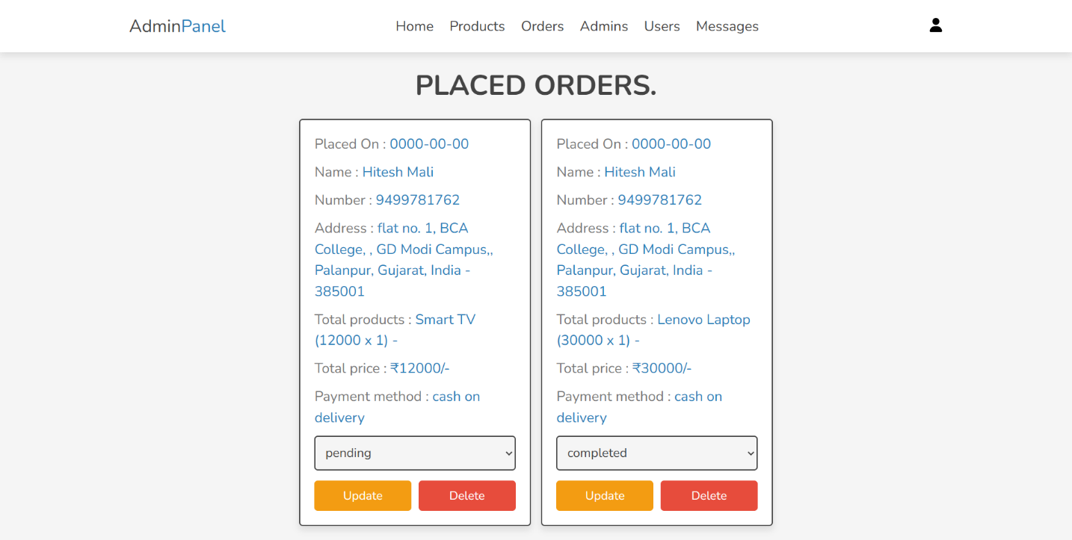

Admin Users Page

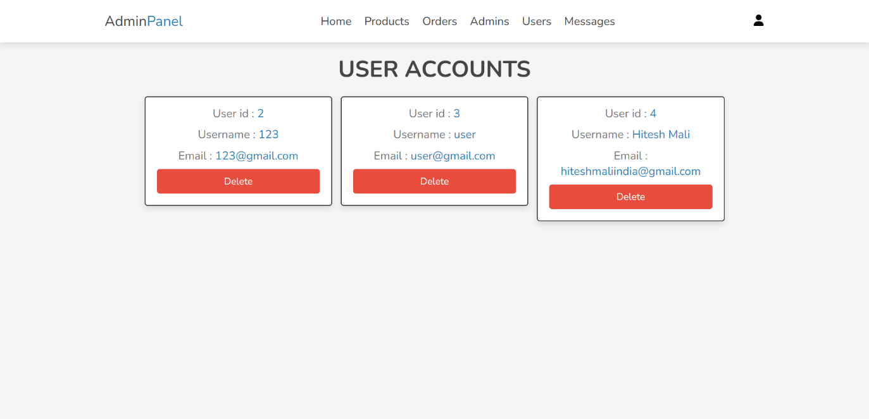

Admin Messages Page

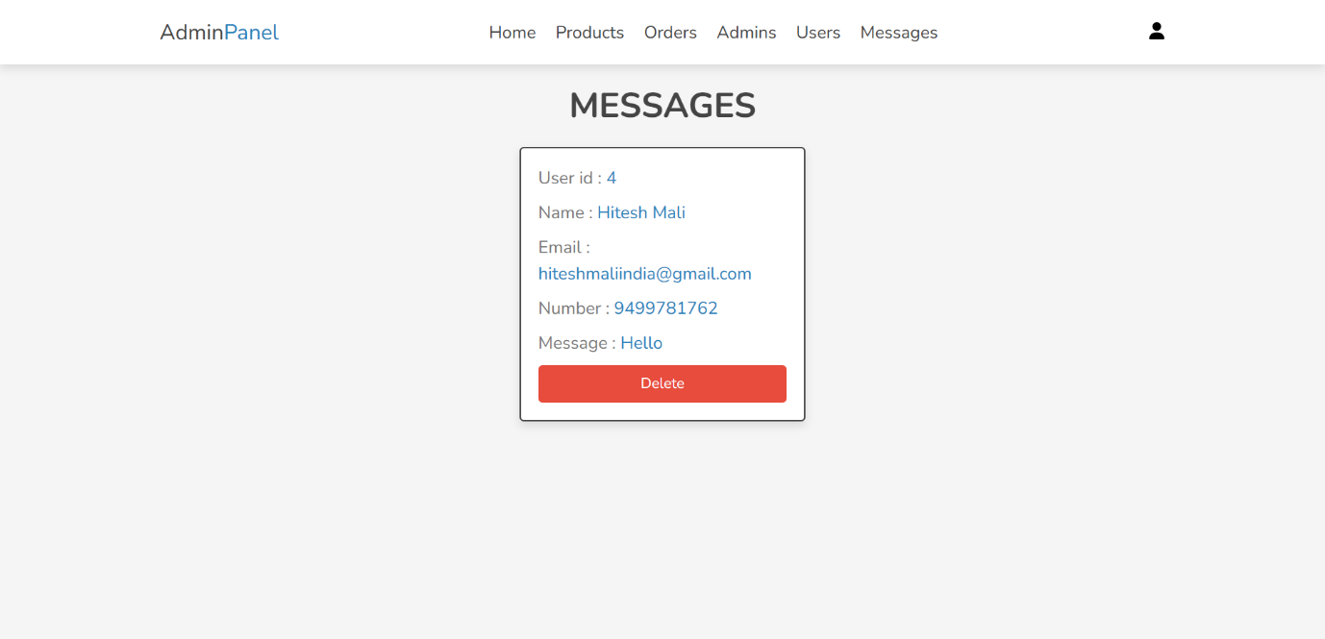

User Register Page

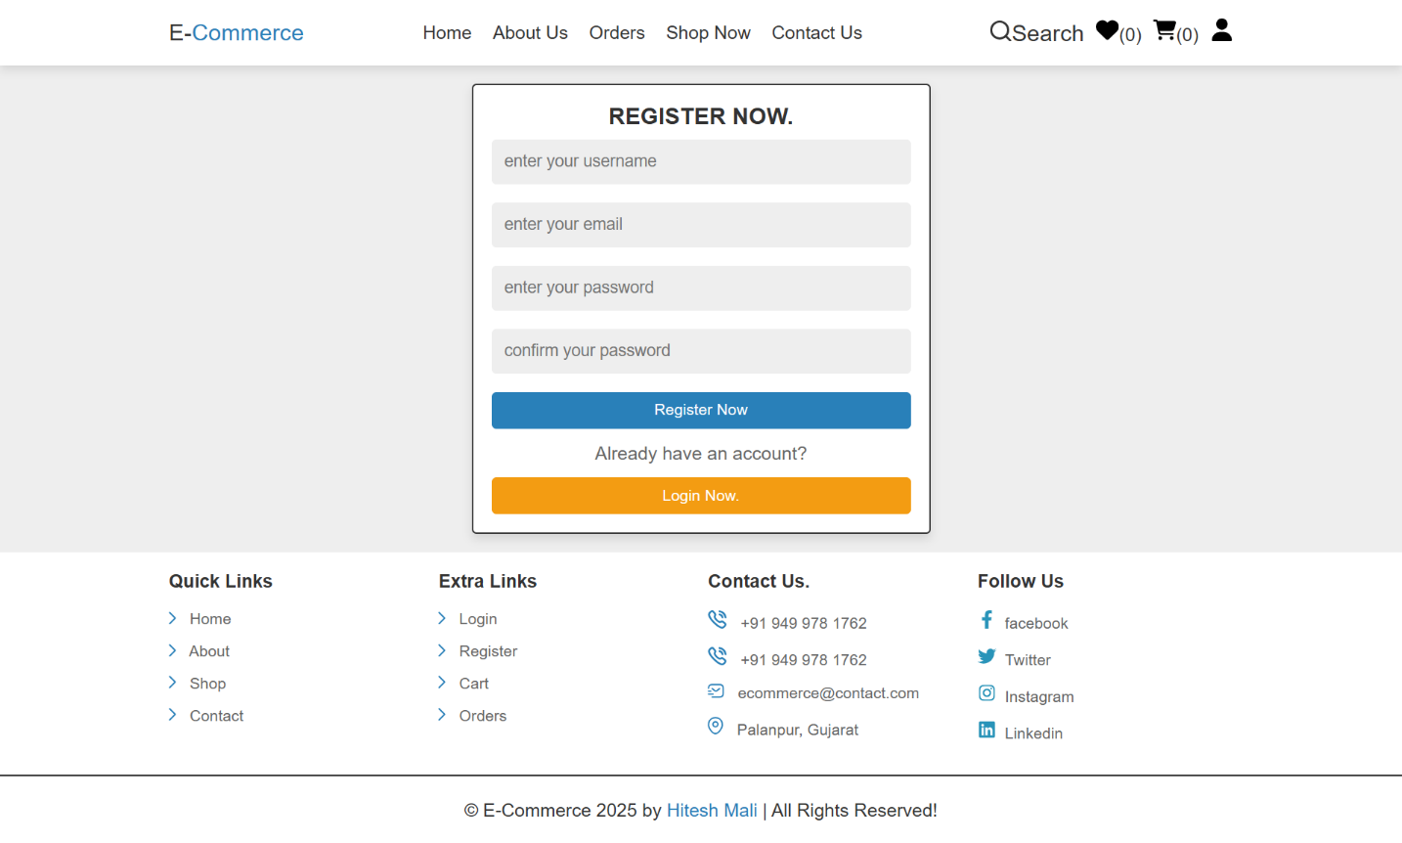

User Login Page

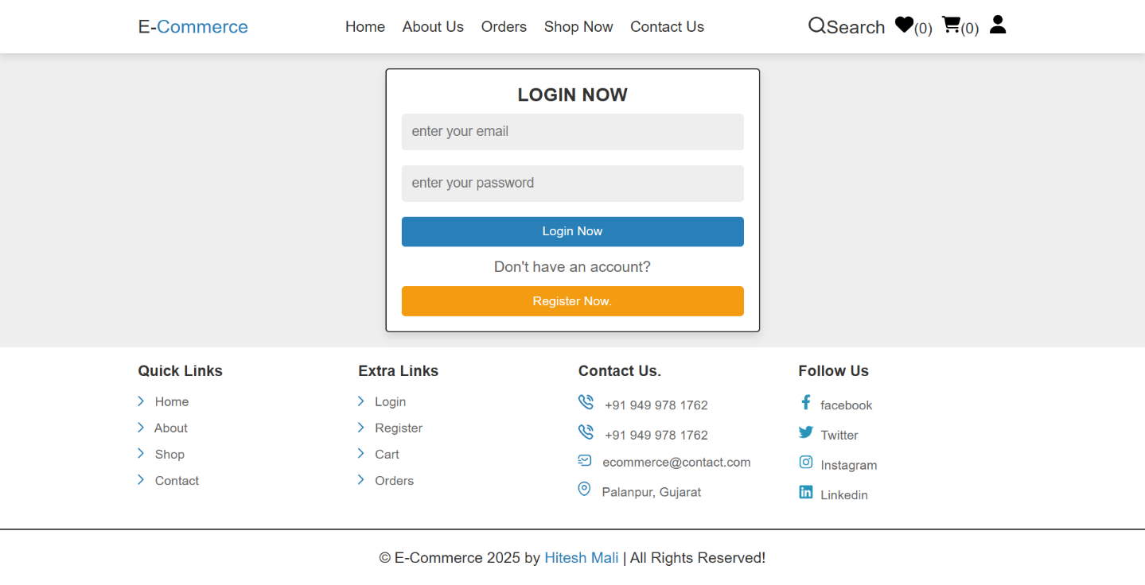

User Update Profile Page

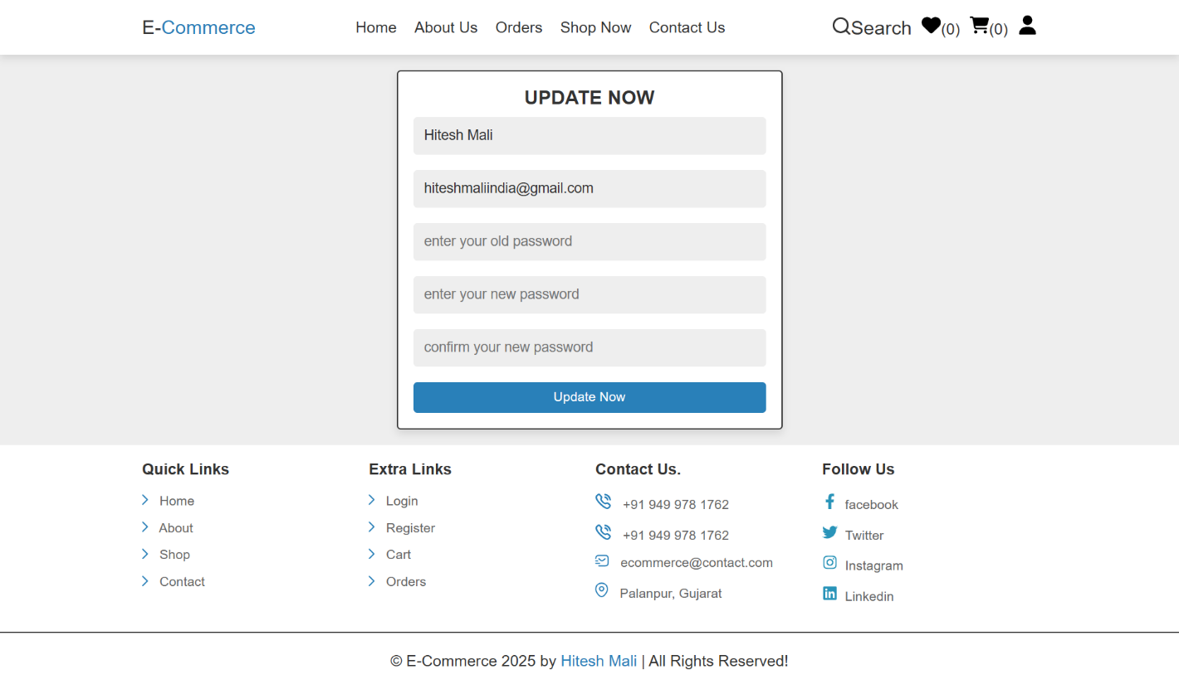

Home Page

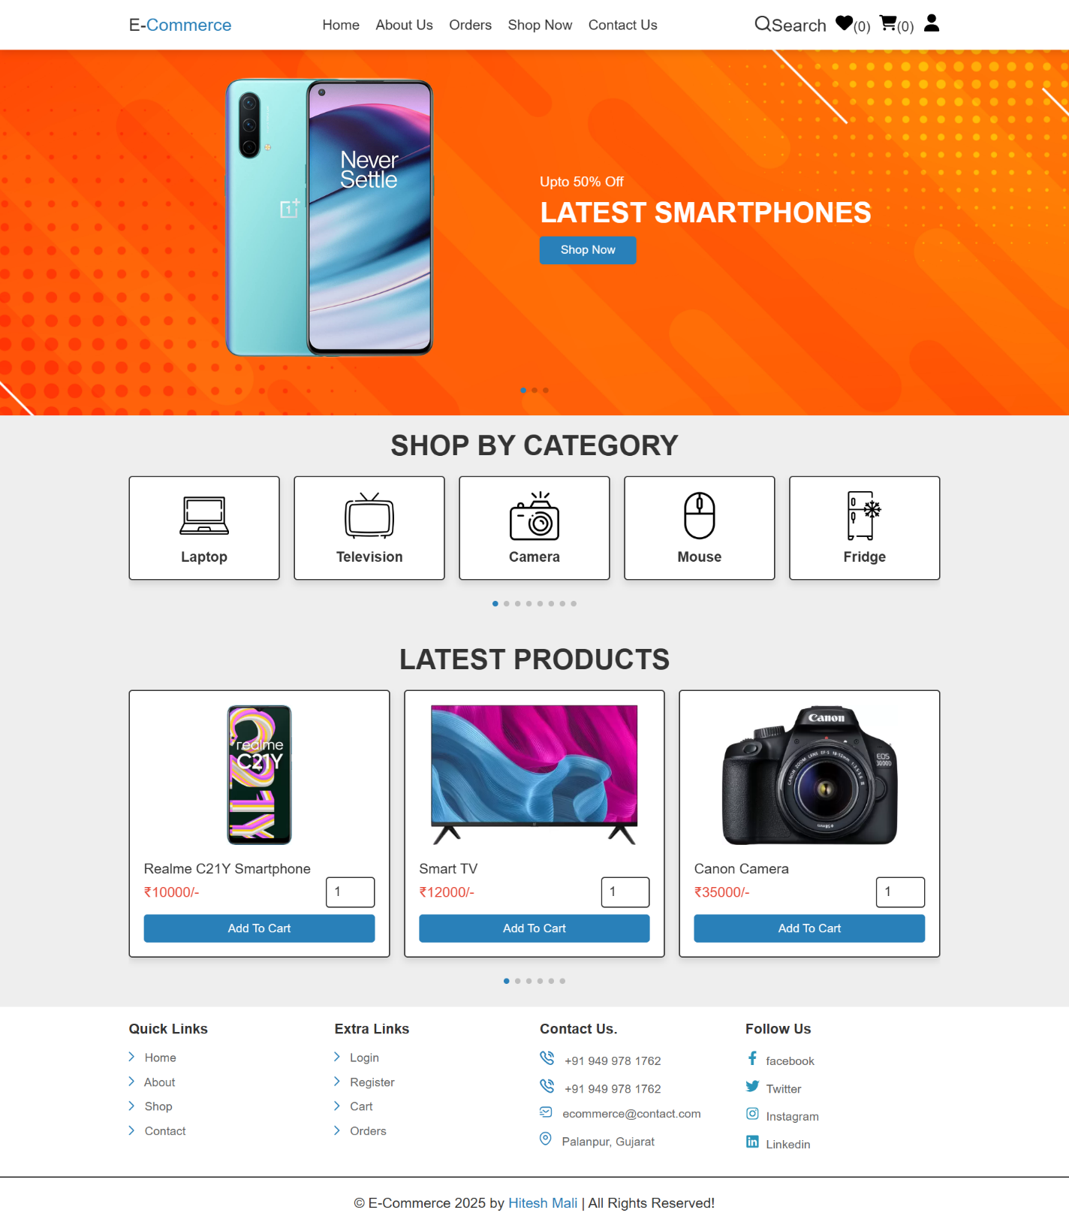

About Page



Shop Page

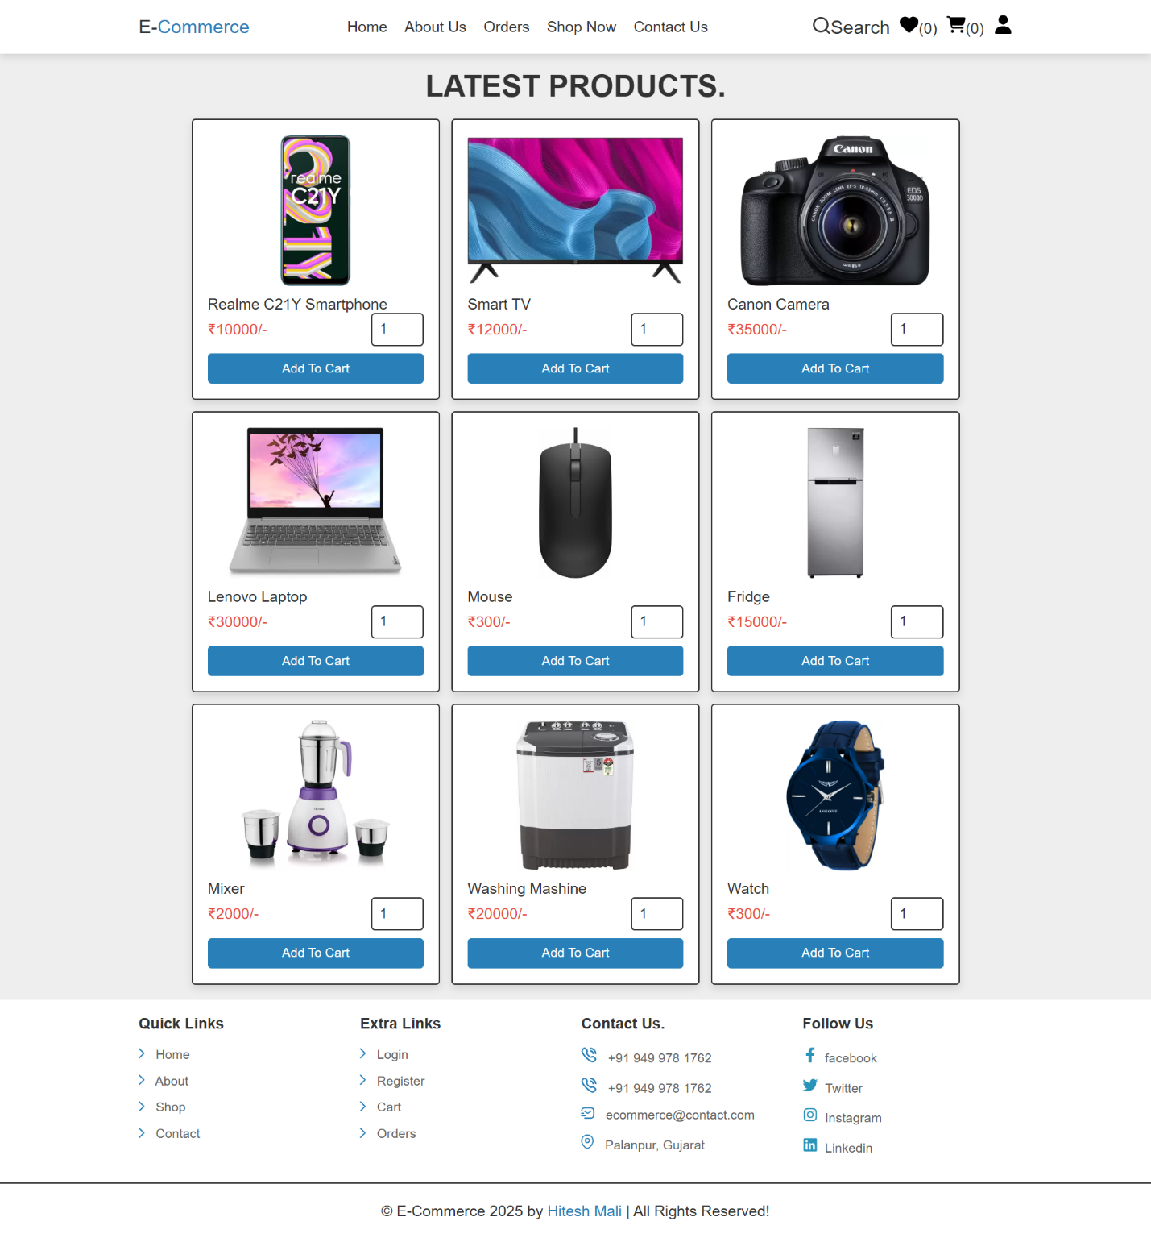

Category Page

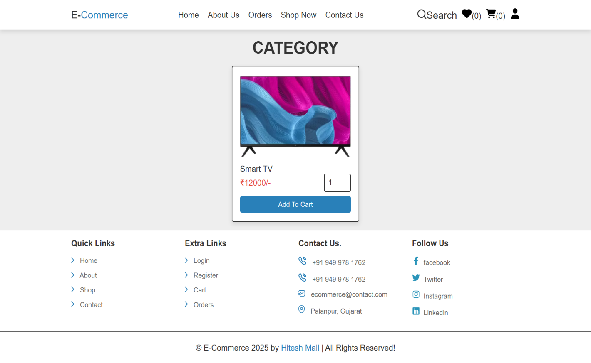

Contact Us Page

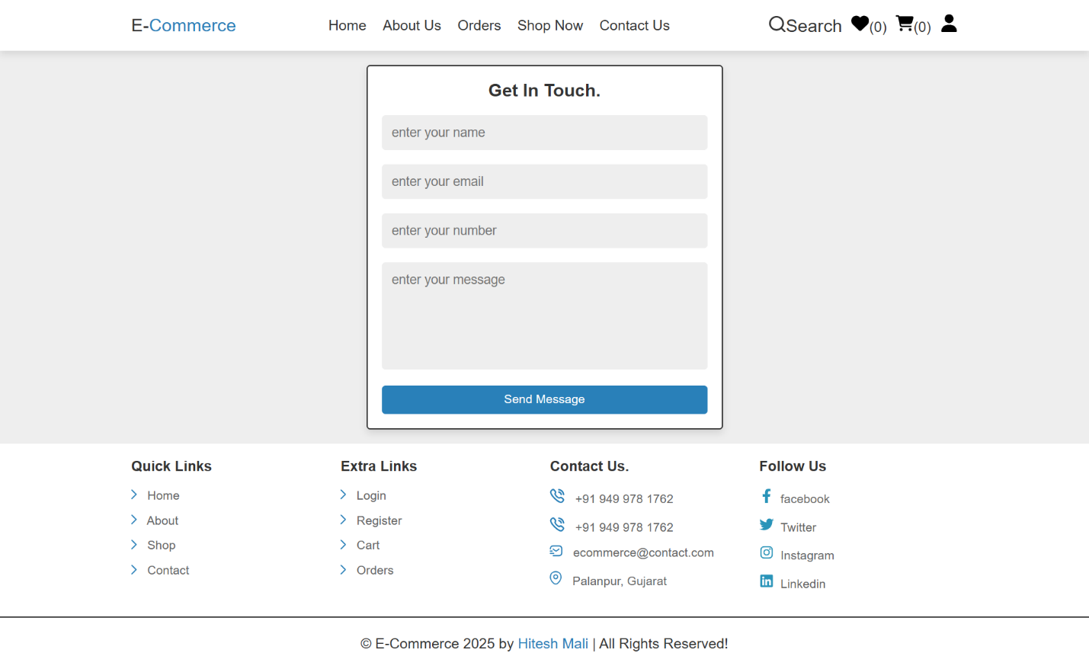

Search Page

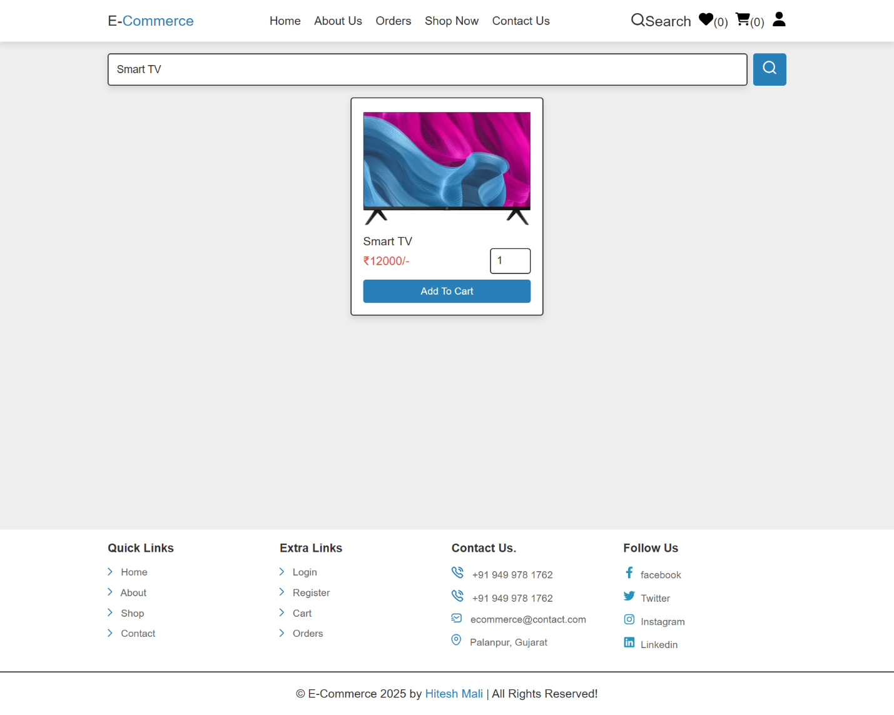

Quick View Page

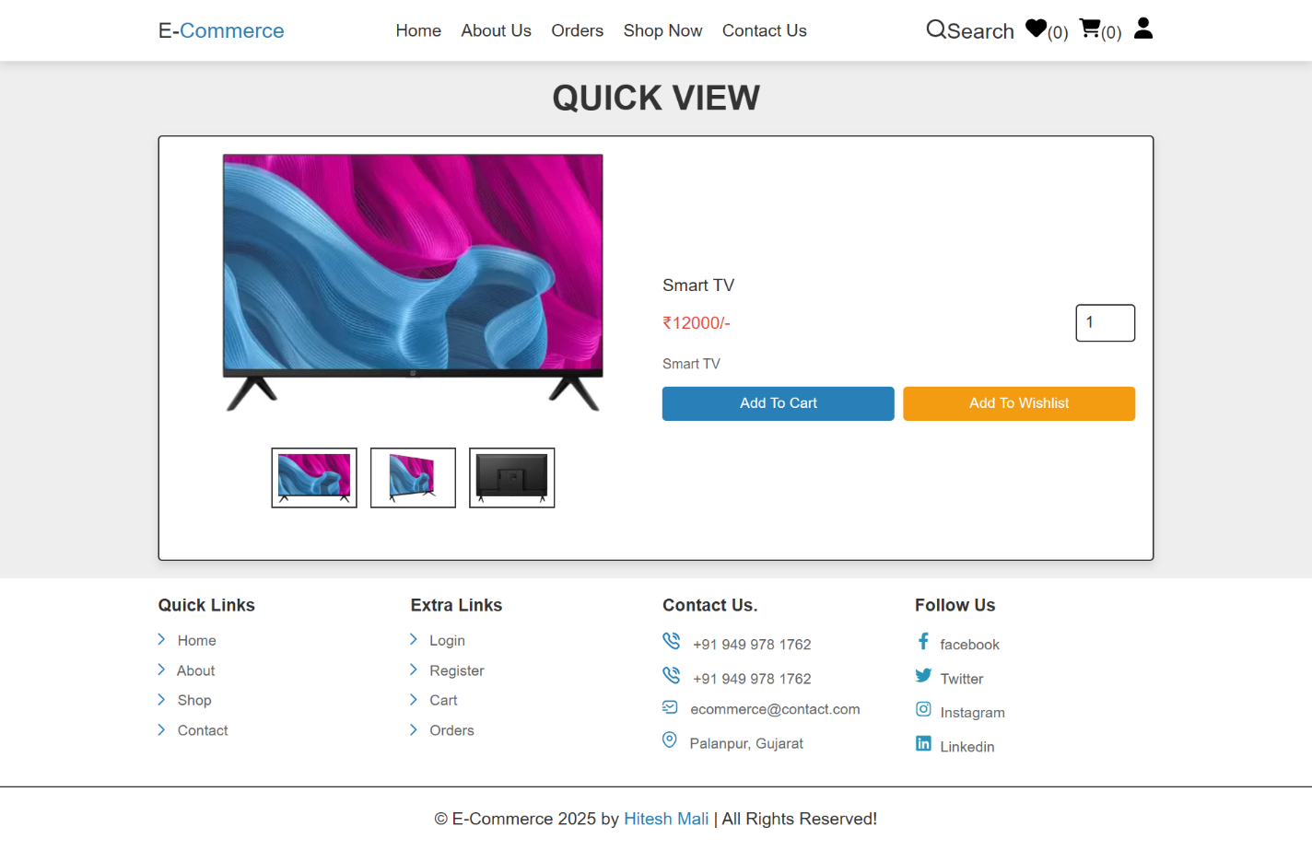

Wishlist Page

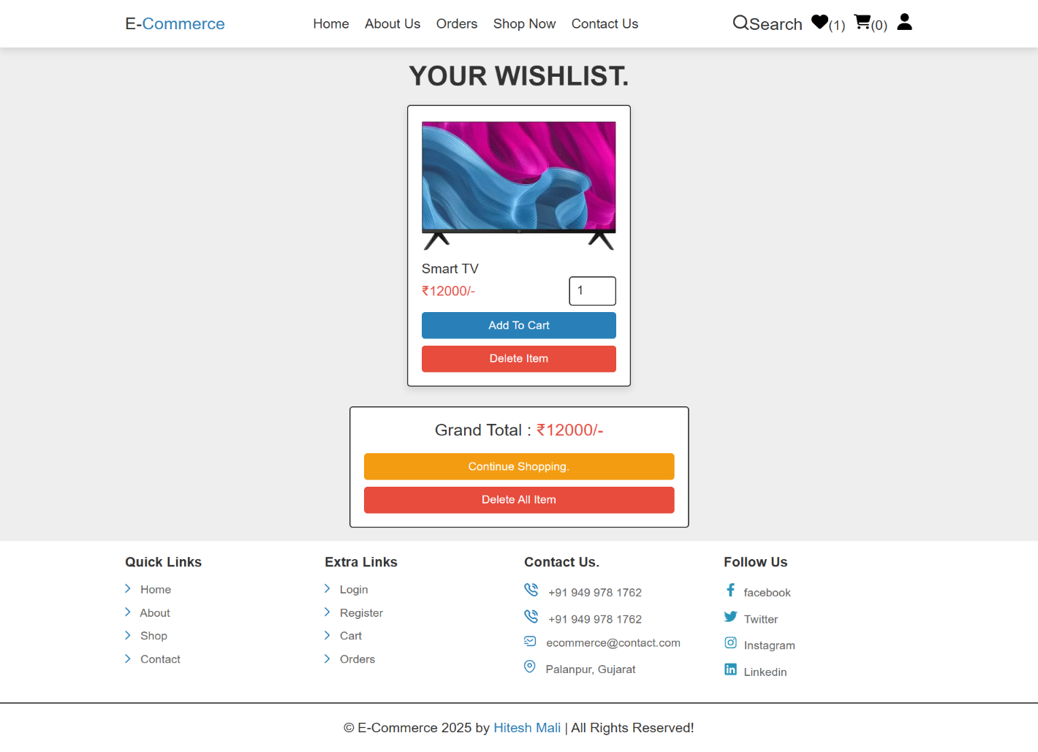

Cart Page

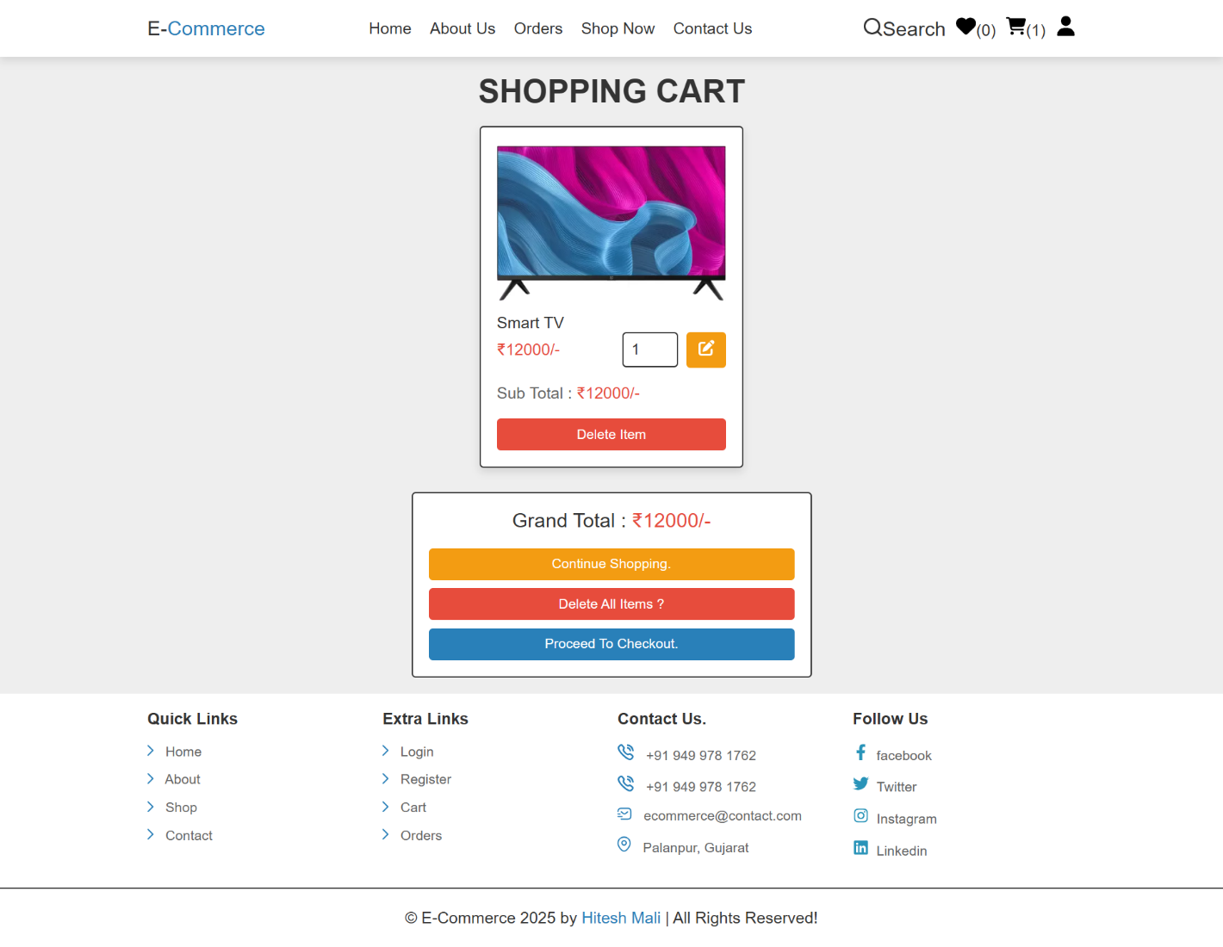

Checkout Page

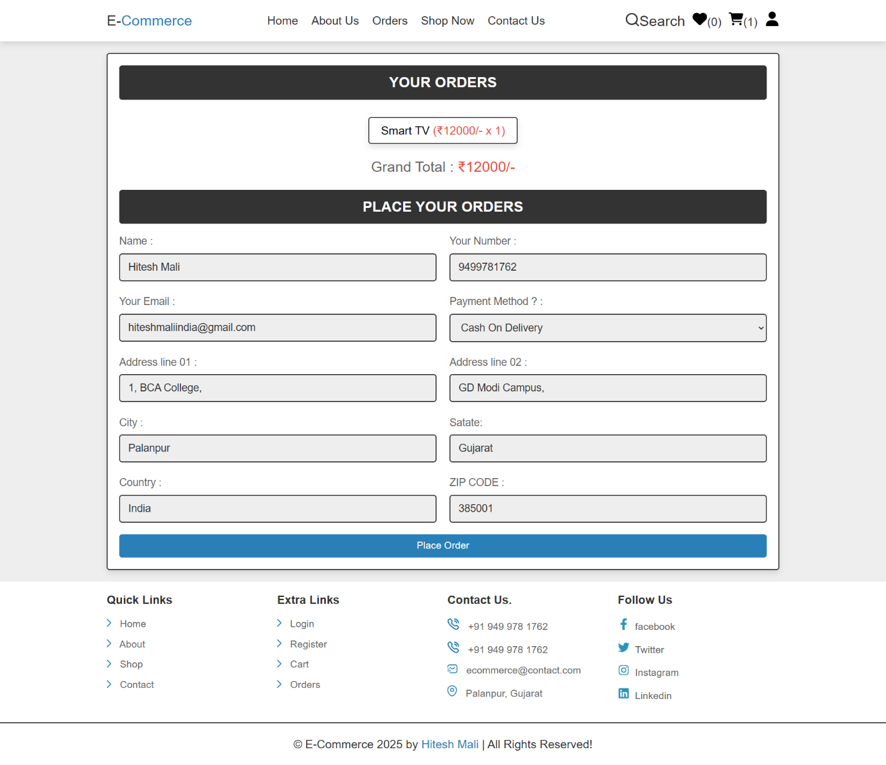

Orders Page

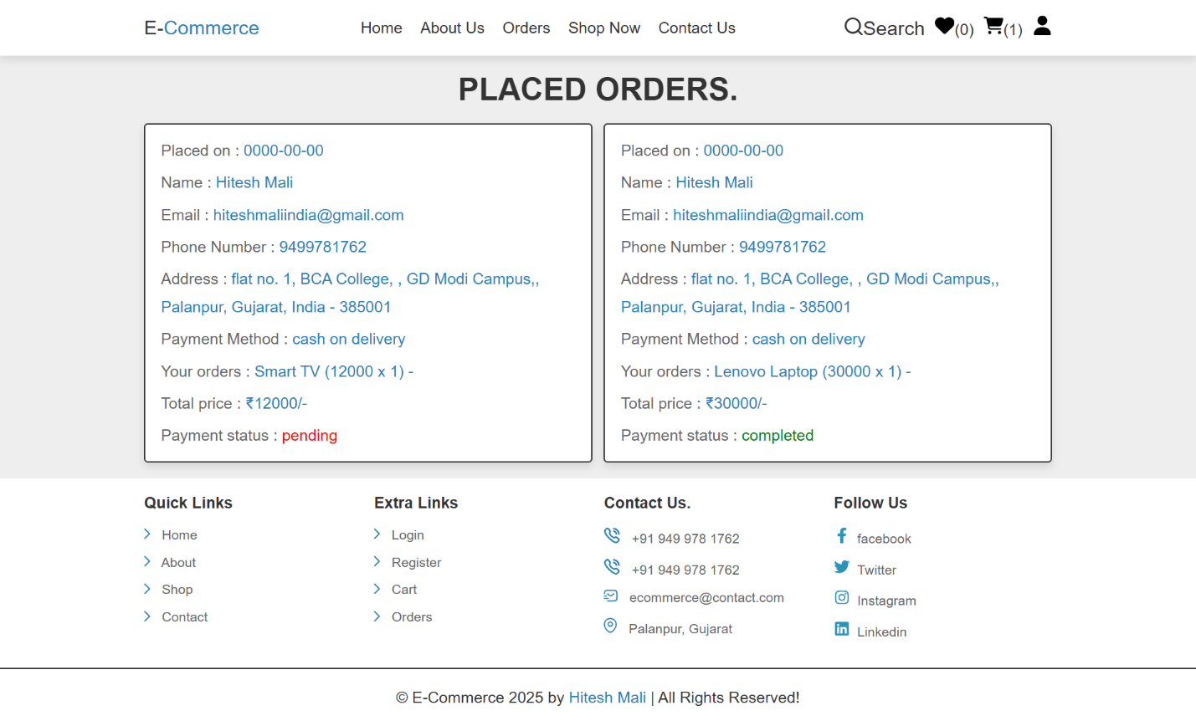

**7.0** **References:**

* [ChatGPT](https://www.geeksforgeeks.org/)
* <http://www.w3schools.com/>
* <http://www.php.net/>
* <http://www.mysql.com/>
* <http://www.mysqltutorial.org/>
* The Joy PHP Programming : A Beginner’s Guide
* PHP: A Beginner’s Guide
* Learning PHP, MySQL, JavaScript, and CSS
* PHP & MySQL Web Development